Introduction to Cloud Solutions Lab Report
Use this template to document your work as you complete the lab assignment in QA.

Your Information
Your Name:
Lab Title: Creating AWS EC2 Instances Using Templates

Instructions
Follow the instructions to answer the questions related to the lab and add the required screenshots. Submit your completed report following the instructions in Canvas.

Section 1
1. Step 10: What do the YAML and JSON templates share in common?
They share the same Type: "AWS::EC2::Instance" and both uses lines.

2. Step 10: How do the YAML and JSON templates differ from one another?
YAML is structured and looks way easier to understand. Json uses the brackets, quotations, different colors and its lengthier.

3. Step 14 Screenshot: YAML template with URL
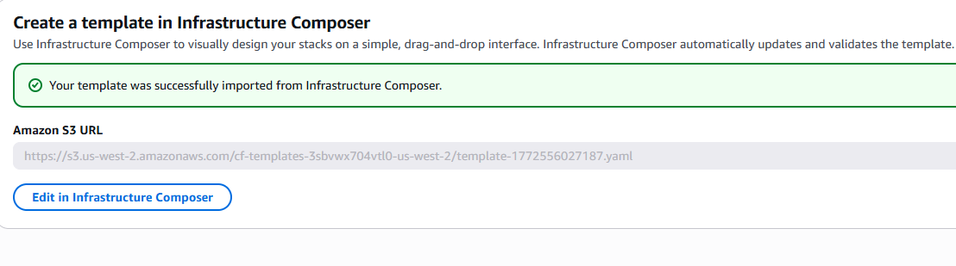

4. Step 30 screenshot: JSON template with URL
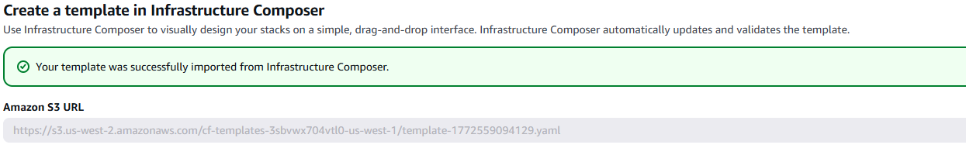

Section 2
5. Step 14: If you received a validation error, what steps did you take to resolve it?
I checked for indentation first. Then, Fix the structure of the code, and I used space instead of tabs. After that, I compared my file to a correct example and fixed any structural issues.

6. Step 14: What do validation errors indicate about the contents of template file?
I indicate there’s something wrong with the template file, like bad indentation, missing properties, or incorrect values. It shows the file doesn’t match up.
7. Step 17 screenshot: YAML template with URL
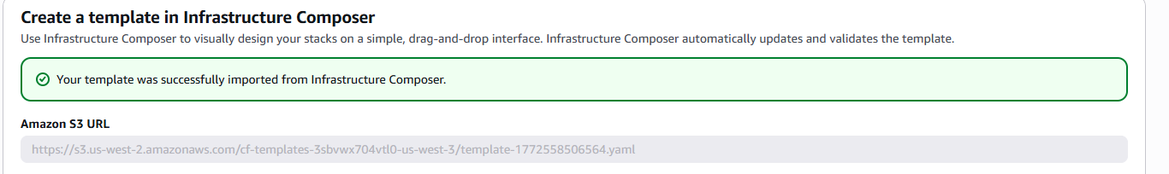

8. Step 28 screenshot: YAML template named stack (include your student ID)
